**Protocol how to prepare VC + Enzyme concentration in water based on molar ratio 1:6 and measure the RI**

Working with enzyme should be done using protective clothing which include gloves, safety glasses and lab coats. Furthermore, enzyme activity can be affected by a variety of factors, such as temperature, pH and concentration and sub-optimal conditions can cause an enzyme to lose its ability to bind to a substrate. Avoid over vortexing of enzymes and prepare the fresh batch for each of your experiment. Enzymes should be stored as recommended by the suppliers. However, aliquots of enzymes should avoid constant freezing and thawing of the products.

**Method for Ratio of 1:6**

**Materials required**

1. 20 µl of Vinyl chloride (2000 µg/ml in Methanol)
2. 2.5 ml of DI water for cuvette and 2 ml of water to prepare enzyme
3. 2 mg of Enzyme PH450 in 2 ml of water from where we extract and use 0.227 µl

**Equipment**

1. Spectrophotometer
2. Micropipette and plastic caps
3. Nano-cuvette™ One
4. Spectro-link
5. PC/tablet/laptop

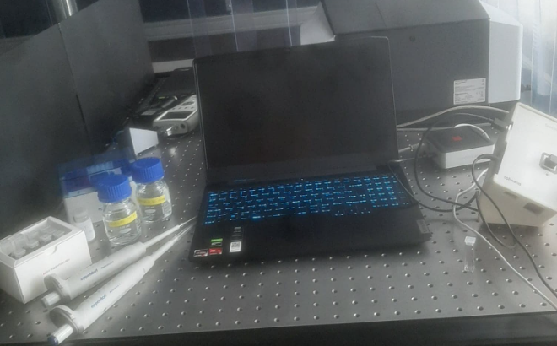

**Procedure to measure refractive index using Nano-cuvette One and Spectro-works**

**Measure RI for water to use it as a Reference in the “Choose reference” list.**

1. Turn on the spectrophotometer and stabilize it by letting it sit for at least 15 minutes before running any samples.
2. Set up the spectrophotometer for “number of scans” and “Integration time”
3. Choose “Create” and select the cuvette type.
4. Type in the cuvette batch and select the cuvette number.
5. Pipette 2,5 mL of reference DI water in Nano-cuvette™ One.
6. From the “reference list” choose the reference liquid to be water.
7. Insert the reference sample (water) cuvette into the sample chamber of spectrophotometer and run the B side measurement first (with the photonic crystal).
8. Now it requires to measure the sample, in this case the sample is water. Turn the cuvette 90 degree and run the A side measurement. Next step is to turn the cuvette with the B side again and run the measurement. Don’t forget to name the measurement in the notes as water test.
9. **OBS! Please save the measurement only if the Sample fit quality is greater than 80 %.**

**Measure RI for water and VC**

1. After you had measured the RI for water (see measure RI for water), you must select from the “choose reference” list the measurement for water which was done before.
2. Pipette the desire 20 µl of VC in the Nano-cuvette™ One. Gently mix the reaction mixture for 30s-1min.
3. Now it requires to measure the B side but **Pres** **back** to go to back to the A side measurement first and insert the cuvette (with the water and VC) into the sample chamber of spectrophotometer and run the A side measurement first (without the photonic crystal).
4. Next turn the cuvette with 90 degrees from previous position, and run the B side measurement (with the photonic crystal).
5. In the end a summary will be generated where you can find the results for water and VC, experiment setup, a graphic plot and notes. Don’t forget to name the measurement in the notes.
6. Repeat the measurement with the same cuvette re-using the water reference made in the beginning. Make the measurements in the following time points: 0min, 5min, 10min, 15min, 20min 25min, 30min, 35min, 40min, 45min, 50min, 55min and 60min.
7. Save the measurements as water + VC test.

**Measure RI for water, VC and enzyme**

1. After you had measured the RI for water, and RI for water + VC, you must perform the measurements adding the enzyme in the water + VC sample.
2. Prepare the enzyme (see the enzyme preparation method below)
3. Pouring the 0.227 µl of Enzyme in the cuvette which contain the water 2.5 ml and 20 µl of VC which was tested before.
4. Next step is to select from the “choose reference” list the measurement reference for water you did it before.
5. Now it requires the measure the B side but **Pres** **back** to go to the A side measurement first and insert the cuvette (with the water, VC and Enzyme) into the sample chamber of spectrophotometer and run the A side measurement first (without the photonic crystal).
6. Next turn the cuvette with 90 degrees from previous position, and run the B side measurement (with the photonic crystal).
7. In the end a summary will be generated where you can find the results, experiment setup, a graphic plot and notes. Don’t forget to name the measurement in the notes as water + VC + Enzyme
8. Repeat the measurement with the same cuvette re-using the water reference made in the beginning. Make the measurements in the following time points: 0min, 5min, 10min, 15min, 20min 25min, 30min, 35min, 40min, 45min, 50min, 55min and 60min.
9. Save the measurements as water + VC + Enzyme with the molar ratio.

**Calculation of Enzyme and Vinyl Chloride for desired molar ratio 1:6 which means 1 mol of VC to 6 mols of Enzyme**

**Vinyl Chloride calculation**

Measure 10 ul of VC with the pipette.

10 µl = 20 µg (20 x10-6 gram), so 20µl of vinyl chloride = 40µg (40 x10-6 gram)

**Convert 40µg of vinyl chloride into moles**

Molar mass of vinyl chloride= 62,498 g/mole

Mass (g)=number of moles/molar mass

Number of moles= mass(g) / molar mass

=40 x10-6 grams / 62,498

= 6.4002 x 10-7 moles

**So 40µg or 20µL of vinyl chloride = 6.4002 micro moles**

**Enzyme calculation**

Take the enzyme out of the freezer and weigh 2 mg of enzyme and add 2 mL of DI water in it. (You can make this mixture in advance but don’t prepare more than half an hour before you use the dissolved enzyme).

Put the rest of enzyme back in the freezer and don’t leave them outside more than 15 min.

Desired molar concentration of enzyme = 6 x 2,4999 micro mole = 14,999 micro moles

Molar mass of enzyme = 55 kDa = 55000 g/mole

Mass (g)=number of moles/molar mass

=14,999 x10-3 /55000

= 0,272 x 10-6 gram =0,272 µg enzymes

=> 0,272 µg of enzyme = 14,999 micro moles

Enzyme stock = 1 mg in 1 mL = 1 µg in 1 µL

If 1 µg = 1µL then, 0,272µg = 0,272µL = 0,272µL enzymes

**So 0,272µg = 0,272µL of enzyme= 14,99 micro moles**

**Caution:** Working with enzyme should be done using protective clothing which include gloves, safety glasses and lab coats. Furthermore, enzyme activity can be affected by a variety of factors, such as temperature, pH and concentration and sub-optimal conditions can cause an enzyme to lose its ability to bind to a substrate.

**Note:** Always use a new plastic cap before using the micropipette!